Modeling RNA Secondary Structures Using Tree Grammars
Satoshi Kobayashi, Takashi Yokomori
Proceedings of Genome Informatics Workshop V, Universal Academy Press, pages 29-38, 1994.
Abstract
This paper proposes a grammatical tool, called tree adjunct grammar with tag for RNA ( denoted by TAG²_{RNA}), for representing structures of RNAs, and shows some example TAG²_{RNA} grammars for fairly complicated RNA secondary structures.
- Introduction
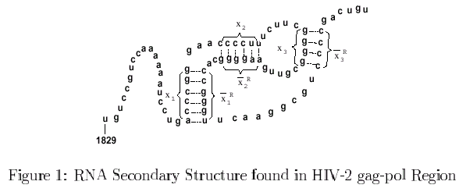

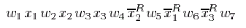
- Preliminaries
(p, q) and (r, s) in a secondary structure are crossing iff either p < r < q < s or r < p < s < q holds.
A secondary structure T is said to have n-crossing property iff there exists a subset T₁ of T with #T₁ = n>=2 such that any distinct elements (p, q) and (r, s) in T₁ are crossing.

A reversal crossing dependency:
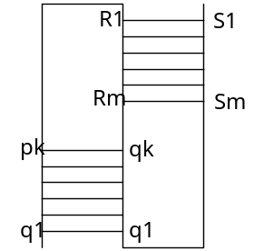
- Tree Adjunct Grammars with Tag
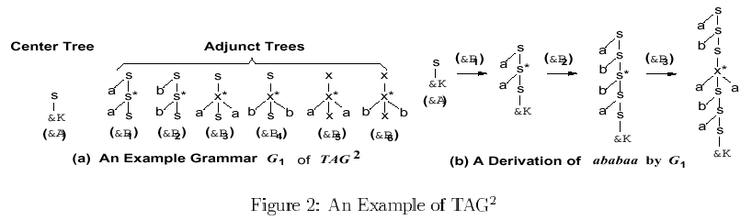

A tree adjunct grammar with tag(TAG², for short) G is a triple G = (C, A, F), where F is a subset of non-terminal symbols.Set C and A are called the sets of center trees and adjunct trees, respectively.
- Specialized TAG² for Modeling RNA secondary Structures
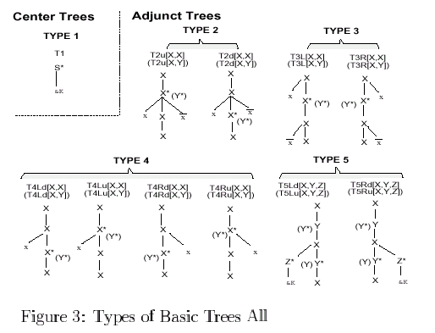
- Basic Properties of TAG²_{RNA}
- Composition of RNAs with High Structural Complexity
Property1: The class of languages generated by TAG²_{RNA} is closed under union, concatenation, insertion
- On Planarity of RNA Secondary Structures.
Property2: Any non-planar secondary structure has 3-crossing property.
Property3: Any secondary structure generated by a grammar in TAG²_{RNA} has no 3-crossing property.
Property4: Any secondary structure generated by a grammar in TAG²_{RNA} is planar.
6. Future Works
Created by: Ming-Cheng Lin
Date: Dec. 7, 2000

